# Case study 1

**5.1 Create appropriate Test Cases for the case study**

1. Test case for 5.2

a) Test Case for Inserting NRI Customer

b) Test Case for Inserting Indian Customer (IND)

c) Test Case for Inserting Customer with Invalid Type

2. Test case for 5.3

a) Valid Transfer from Existing Account to Existing Account

b) Valid Transfer from Existing Account to Non-Existing Account

c) Invalid Customer ID (Non-Existing)

d) For amount less than zero

e) Insufficient Balance for Transfer

f) To Account Number is Null

g) Transfer from Null Account to Non-Existing Account (Null To Account)

h) Transfer from Non-Existing Customer

**5.2 Write a procedure to accept customer name, address, and customer type and account type. Insert the details into the respective tables.**

CREATE OR REPLACE PROCEDURE insert_customer(

name customer_masters.cust_name%TYPE,

address customer_masters.address%TYPE,

c_type customer_masters.Customer_Type%TYPE,

a_type account_masters.account_Type%TYPE

) AS

c_id number := cust_seq.nextval;

a_id number := acc_seq.nextval;

min_bal number;

BEGIN

IF a_type = 'SAV' then

min_bal := 5000;

ELSIF a_type = 'SAL' then

min_bal := 0;

END IF;

INSERT INTO customer_masters VALUES (c_id, name, address, SYSDATE, c_type);

INSERT INTO account_masters VALUES (a_id, c_id, a_type, min_bal);

COMMIT;

DBMS_OUTPUT.PUT_LINE('Row inserted');

END;

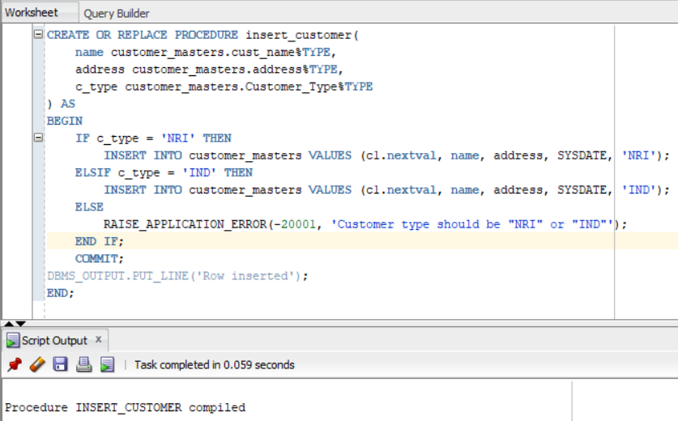

**5.3 Write a procedure to accept customer id, amount and the account number to which the customer requires to transfer money. Following validations need to be done**

* **Customer id should be valid**
* **From account number should belong to that customer**
* **To account number cannot be null but can be an account which need not exist in account masters (some other account)**
* **Adequate balance needs to be available for debit**

CREATE OR REPLACE PROCEDURE transfer_money (

c_id IN NUMBER,

amt IN NUMBER,

to_acc_no IN NUMBER

) AS

v_from_acc_no NUMBER;

v_from_acc_bal NUMBER;

v_to_acc_bal NUMBER;

v_c_exist NUMBER;

BEGIN

-- Validation: Check if the customer id is valid

SELECT COUNT(*) INTO v_c_exist FROM customer_masters WHERE Cust_Id = c_id;

IF v_c_exist = 0 THEN

RAISE_APPLICATION_ERROR(-20001, 'Invalid customer id.');

ELSIF v_c_exist > 1 THEN

RAISE_APPLICATION_ERROR(-20002, 'Multiple customers found for the same id.');

END IF;

-- Validation: To account number cannot be null

IF to_acc_no IS NULL THEN

RAISE_APPLICATION_ERROR(-20004, 'To account number cannot be null.');

END IF;

-- Validation: To account number cannot be null

IF amt <= 0 THEN

RAISE_APPLICATION_ERROR(-20005, 'The amount should be grater than 0.');

END IF;

-- Validation: From account number should belong to that customer

SELECT Ledger_Balance, Account_Number INTO v_from_acc_bal, v_from_acc_no

FROM Account_Masters

WHERE Cust_ID = c_id;

IF v_from_acc_bal IS NULL THEN

RAISE_APPLICATION_ERROR(-20007, 'From account does not belong to the customer.');

END IF;

-- Validation: Adequate balance needs to be available for debit

IF v_from_acc_bal < amt THEN

RAISE_APPLICATION_ERROR(-20003, 'Insufficient balance for the requested transfer.');

END IF;

-- Perform the money transfer

UPDATE Account_Masters

SET Ledger_Balance = v_from_acc_bal - amt

WHERE Cust_ID = c_id;

INSERT INTO transaction_masters values(transact_seq.nextval, v_from_acc_no, sysdate, v_from_acc_no, to_acc_no, amt, 'CR');

-- Update the target account balance only if it exists

BEGIN

SELECT Ledger_Balance INTO v_to_acc_bal

FROM Account_Masters

WHERE Account_Number = to_acc_no;

-- Update the target account balance

UPDATE Account_Masters

SET Ledger_Balance = NVL(v_to_acc_bal, 0) + amt

WHERE Account_Number = to_acc_no;

INSERT INTO transaction_masters values(transact_seq.nextval, to_acc_no, sysdate, v_from_acc_no, to_acc_no, amt, 'DB');

EXCEPTION

WHEN NO_DATA_FOUND THEN

NULL;

END;

DBMS_OUTPUT.PUT_LINE('Money transfer successful.');

COMMIT;

EXCEPTION

WHEN OTHERS THEN

ROLLBACK;

DBMS_OUTPUT.PUT_LINE('Error: ' || SQLCODE || ' - ' || SQLERRM);

END;

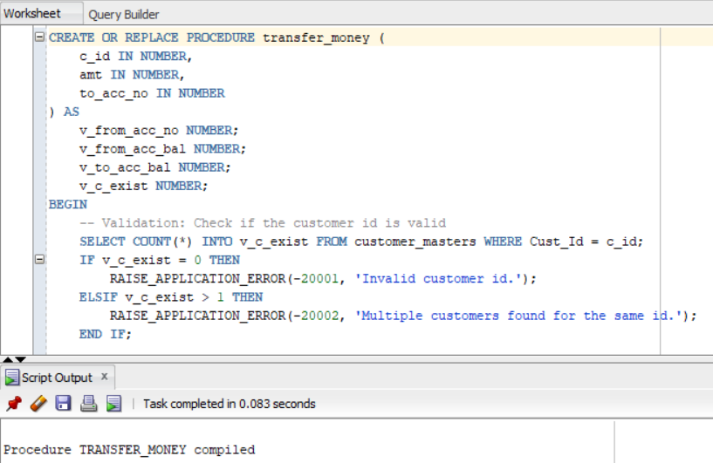

-- Package Specification

CREATE OR REPLACE PACKAGE case_study_1 AS

PROCEDURE insert_customer(

name customer_masters.cust_name%TYPE,

address customer_masters.address%TYPE,

c_type customer_masters.Customer_Type%TYPE,

a_type account_masters.account_Type%TYPE

);

PROCEDURE transfer_money (

c_id IN NUMBER,

amt IN NUMBER,

to_acc_no IN NUMBER

);

END;

-- Package Body

CREATE OR REPLACE PACKAGE BODY case_study_1 AS

PROCEDURE insert_customer(

name customer_masters.cust_name%TYPE,

address customer_masters.address%TYPE,

c_type customer_masters.Customer_Type%TYPE,

a_type account_masters.account_Type%TYPE

) AS

c_id number := cust_seq.nextval;

a_id number := acc_seq.nextval;

min_bal number;

BEGIN

IF a_type = 'SAV' then

min_bal := 5000;

ELSIF a_type = 'SAL' then

min_bal := 0;

END IF;

INSERT INTO customer_masters VALUES (c_id, name, address, SYSDATE, c_type);

INSERT INTO account_masters VALUES (a_id, c_id, a_type, min_bal);

COMMIT;

DBMS_OUTPUT.PUT_LINE('Row inserted');

END;

PROCEDURE transfer_money (

c_id IN NUMBER,

amt IN NUMBER,

to_acc_no IN NUMBER

) AS

v_from_acc_no NUMBER;

v_from_acc_bal NUMBER;

v_to_acc_bal NUMBER;

v_c_exist NUMBER;

BEGIN

-- Validation: Check if the customer id is valid

SELECT COUNT(*) INTO v_c_exist FROM customer_masters WHERE Cust_Id = c_id;

IF v_c_exist = 0 THEN

RAISE_APPLICATION_ERROR(-20001, 'Invalid customer id.');

ELSIF v_c_exist > 1 THEN

RAISE_APPLICATION_ERROR(-20002, 'Multiple customers found for the same id.');

END IF;

-- Validation: To account number cannot be null

IF to_acc_no IS NULL THEN

RAISE_APPLICATION_ERROR(-20004, 'To account number cannot be null.');

END IF;

-- Validation: To account number cannot be null

IF amt <= 0 THEN

RAISE_APPLICATION_ERROR(-20005, 'The amount should be grater than 0.');

END IF;

-- Validation: From account number should belong to that customer

SELECT Ledger_Balance, Account_Number INTO v_from_acc_bal, v_from_acc_no

FROM Account_Masters

WHERE Cust_ID = c_id;

IF v_from_acc_bal IS NULL THEN

RAISE_APPLICATION_ERROR(-20007, 'From account does not belong to the customer.');

END IF;

-- Validation: Adequate balance needs to be available for debit

IF v_from_acc_bal < amt THEN

RAISE_APPLICATION_ERROR(-20003, 'Insufficient balance for the requested transfer.');

END IF;

-- Perform the money transfer

UPDATE Account_Masters

SET Ledger_Balance = v_from_acc_bal - amt

WHERE Cust_ID = c_id;

INSERT INTO transaction_masters values(transact_seq.nextval, v_from_acc_no, sysdate, v_from_acc_no, to_acc_no, amt, 'CR');

-- Update the target account balance only if it exists

BEGIN

SELECT Ledger_Balance INTO v_to_acc_bal

FROM Account_Masters

WHERE Account_Number = to_acc_no;

-- Update the target account balance

UPDATE Account_Masters

SET Ledger_Balance = NVL(v_to_acc_bal, 0) + amt

WHERE Account_Number = to_acc_no;

INSERT INTO transaction_masters values(transact_seq.nextval, to_acc_no, sysdate, v_from_acc_no, to_acc_no, amt, 'DB');

EXCEPTION

WHEN NO_DATA_FOUND THEN

NULL;

END;

DBMS_OUTPUT.PUT_LINE('Money transfer successful.');

COMMIT;

EXCEPTION

WHEN OTHERS THEN

ROLLBACK;

DBMS_OUTPUT.PUT_LINE('Error: ' || SQLCODE || ' - ' || SQLERRM);

END;

END;

**5.4 Ensure all the Test cases defined are executed**

1. Test case for 5.2

a) Test Case for Inserting NRI Customer:

exec insert_customer('John Doe', '123 Main St', 'NRI',’SAL’);

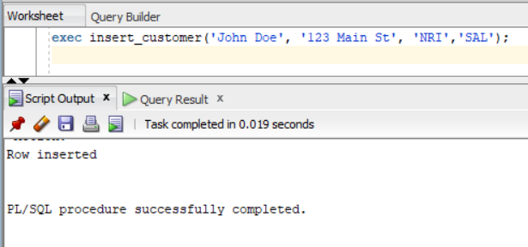

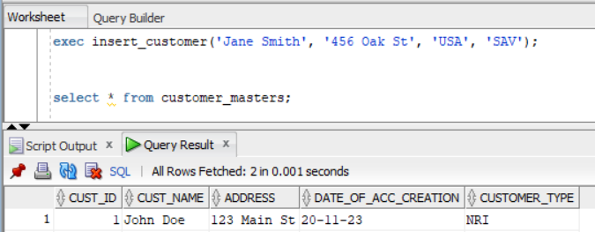

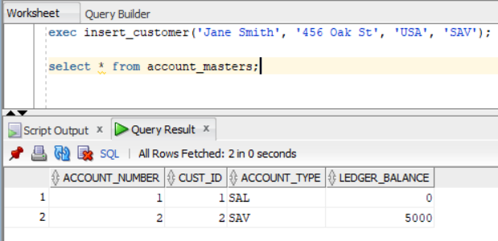

2. Test case for 5.3

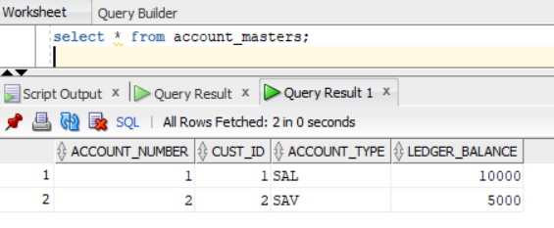

a) Valid Transfer from Existing Account to Existing Account:

exec transfer_money(1, 500, 2);

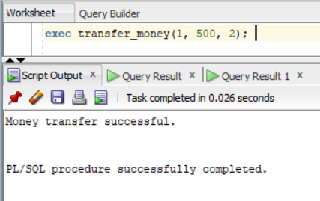

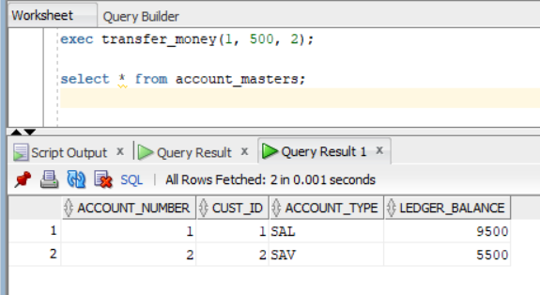

b) Valid Transfer from Existing Account to Non-Existing Account:

exec transfer_money(1, 300, 999);

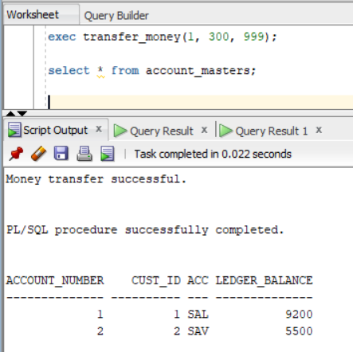

c) Invalid Customer ID (Non-Existing):

exec transfer_money(999, 200, 2);

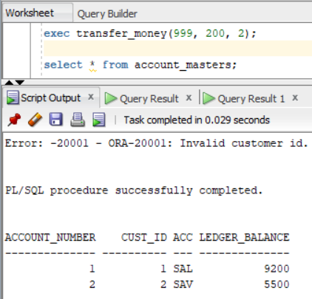

d) For amount less than zero:

exec transfer_money(1, -150, 2);

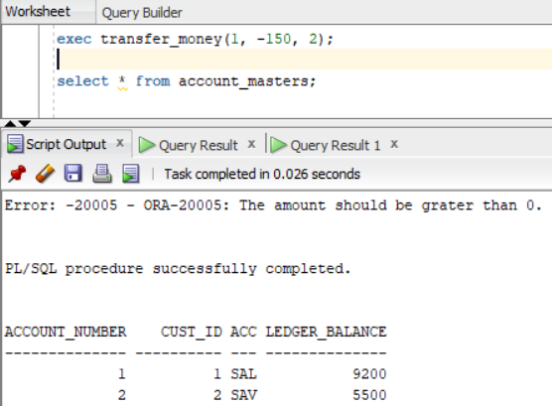

e) Insufficient Balance for Transfer:

exec transfer_money(1, 10000, 2);

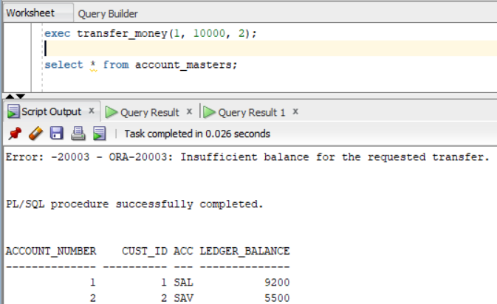

f) To Account Number is Null:

exec transfer_money(1, 200, NULL);

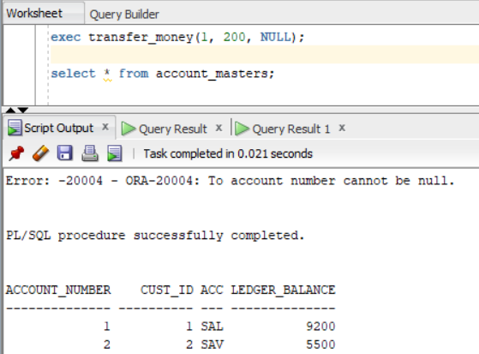

g) Transfer from Null Account to Non-Existing Account (Null To Account):

exec transfer_money(NULL, 300, 6);

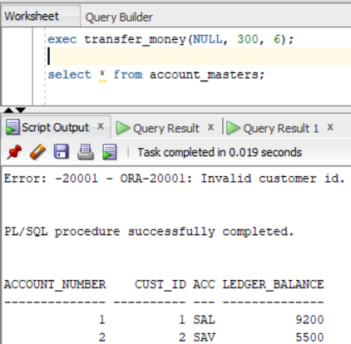

# Case study 2

**6.1 Create appropriate Test Cases for the case study followed up by Self/Peer to Peer**

1. Test case for 6.2
   1. Valid case for add_emp
   2. Invalid case for add_emp
   3. Valid case for raise_sal
   4. Invalid case for raise_sal
   5. Valid case for remove_emp
   6. Invalid case for remove_emp
2. Test case for 6.3
   1. Valid case for add_emp
   2. Invalid case for add_emp
   3. Valid case for raise_sal
   4. Invalid case for raise_sal
   5. Valid case for remove_emp
   6. Invalid case for remove_emp
3. Test case for 6.4
   1. Test Case for Inserting a New Employee
   2. Test Case for Updating Employee Salary (within the limit)
   3. Test Case for Updating Employee Salary (exceeding the limit)
   4. Test Case for Deleting an Employee
   5. Test Case for Deleting Non-Existent Employee (no_data_found scenario)

**6.2 Recreate the procedure (run_task) which is more efficient in performing the same.**

CREATE OR REPLACE PROCEDURE run_task (

task_number_in IN INTEGER,

emp_number_in IN NUMBER DEFAULT NULL,

ename_in IN VARCHAR2 DEFAULT NULL,

city_in IN VARCHAR2 DEFAULT NULL,

designation_in IN VARCHAR2 DEFAULT NULL,

salary_in IN NUMBER DEFAULT NULL

)

IS

BEGIN

CASE task_number_in

WHEN 1 THEN

add_emp(ename_in, city_in, designation_in, salary_in);

WHEN 2 THEN

raise_sal(emp_number_in, salary_in);

WHEN 3 THEN

remove_emp(emp_number_in);

ELSE

RAISE_APPLICATION_ERROR(-20002, 'Invalid task number.');

END CASE;

EXCEPTION

WHEN OTHERS THEN

DBMS_OUTPUT.PUT_LINE('Error: ' || SQLCODE || ' - ' || SQLERRM);

ROLLBACK;

RAISE;

END run_task;

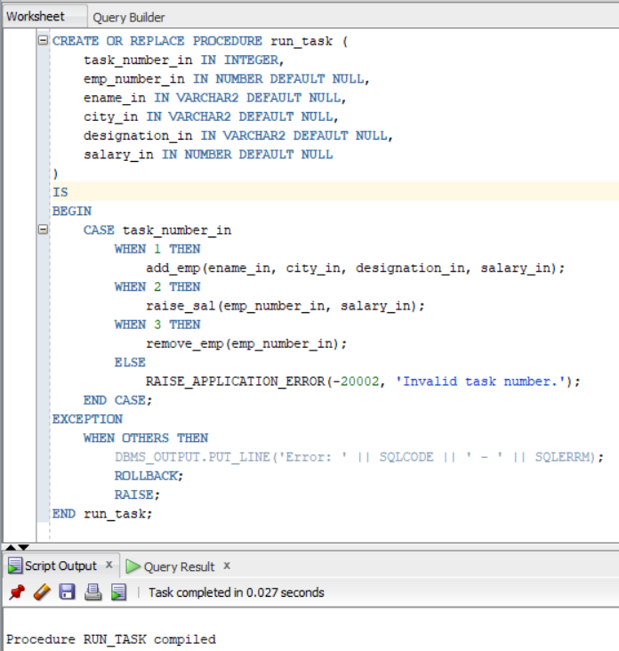

**6.3 Also, create relevant procedures (add_emp , raise_sal ,remove_emp) with relevant logic (read comments)to verify the same.**

CREATE OR REPLACE PROCEDURE add_emp(

v_ename myEmp.ename%type,

v_city myEmp.city%type DEFAULT 'Mumbai',

v_des myEmp.Designation%type,

v_sal myEmp.Salary%type

) AS

BEGIN

INSERT INTO myEmp VALUES (emp_seq.NEXTVAL, v_ename, v_city, v_des, v_sal);

DBMS_OUTPUT.PUT_LINE('Row inserted');

COMMIT;

END add_emp;

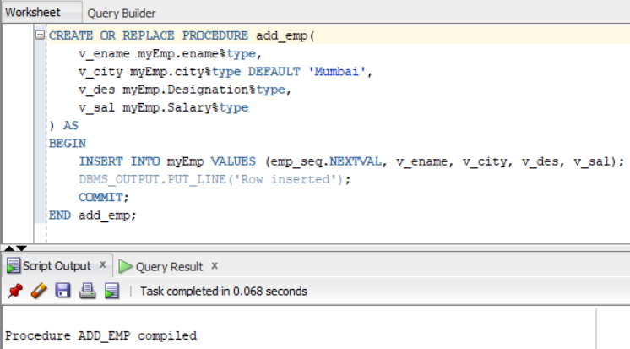

CREATE OR REPLACE PROCEDURE raise_sal (

p_empno IN myEmp.EmpNo%type,

p_sal IN myEmp.Salary%type

) AS

v_current_salary NUMBER;

v_upper_limit NUMBER := 1.30;

BEGIN

SELECT Salary INTO v_current_salary FROM myEmp WHERE EmpNo = p_empno;

IF v_current_salary IS NULL THEN

RAISE_APPLICATION_ERROR(-20001, 'Employee not found.');

END IF;

IF p_sal > v_current_salary * v_upper_limit THEN

RAISE_APPLICATION_ERROR(-20002, 'Salary raise exceeds the 30% limit.');

END IF;

UPDATE myEmp SET Salary = p_sal WHERE EmpNo = p_empno;

DBMS_OUTPUT.PUT_LINE('Row updated');

COMMIT;

EXCEPTION

WHEN OTHERS THEN

DBMS_OUTPUT.PUT_LINE('Error updating salary: ' || SQLCODE || ' - ' || SQLERRM);

ROLLBACK;

RAISE;

END raise_sal;

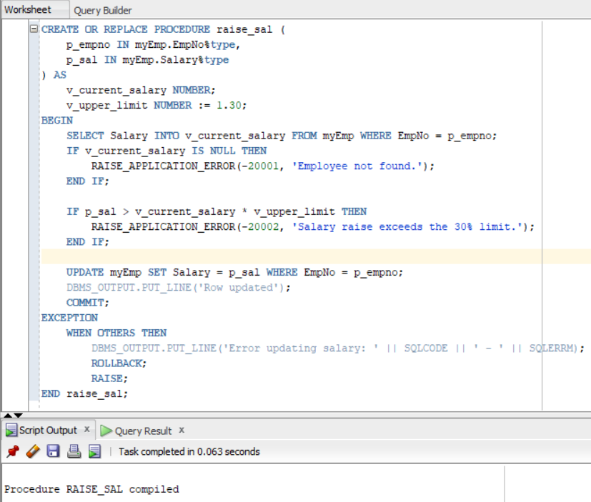

CREATE OR REPLACE PROCEDURE remove_emp(v_empno myEmp.EmpNo%type) AS

v_name VARCHAR2(50);

BEGIN

SELECT ename INTO v_name FROM myEmp WHERE EmpNo = v_empno;

DELETE FROM myEmp WHERE EmpNo = v_empno;

DBMS_OUTPUT.PUT_LINE('Row deleted');

COMMIT;

EXCEPTION

WHEN NO_DATA_FOUND THEN

DBMS_OUTPUT.PUT_LINE('No such employee id');

WHEN OTHERS THEN

DBMS_OUTPUT.PUT_LINE('Error: ' || SQLCODE || ' - ' || SQLERRM);

ROLLBACK;

RAISE;

END remove_emp;

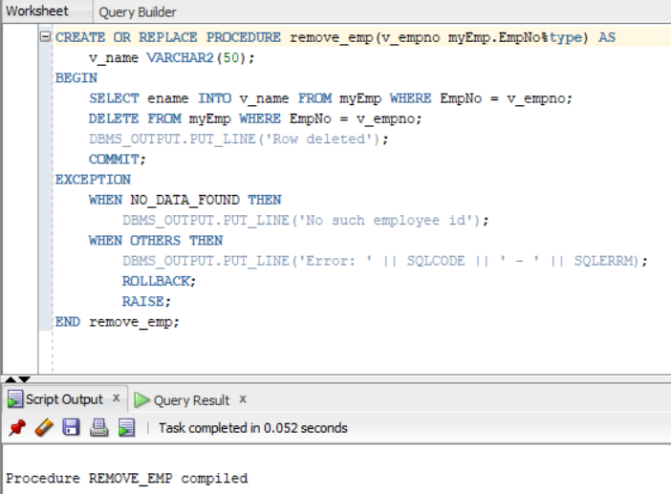

**6.4 Extend the above implementation using Packages**

-- Package Specification

CREATE OR REPLACE PACKAGE case_study_2 AS

PROCEDURE run_task(

ename_in IN VARCHAR2 DEFAULT NULL,

salary_in IN NUMBER DEFAULT NULL,

city_in IN VARCHAR2 DEFAULT 'Mumbai',

designation_in IN VARCHAR2 DEFAULT NULL

);

PROCEDURE run_task(emp_number_in IN NUMBER, salary_in IN NUMBER);

PROCEDURE run_task(emp_number_in IN NUMBER);

END;

-- Package Body

CREATE OR REPLACE PACKAGE BODY case_study_2 AS

PROCEDURE run_task(

ename_in IN VARCHAR2 DEFAULT NULL,

salary_in IN NUMBER DEFAULT NULL,

city_in IN VARCHAR2 DEFAULT 'Mumbai',

designation_in IN VARCHAR2 DEFAULT NULL

) AS

BEGIN

INSERT INTO myEmp VALUES (emp_seq.nextval, ename_in, city_in, designation_in, salary_in);

DBMS_OUTPUT.PUT_LINE('Row inserted');

END;

PROCEDURE run_task(emp_number_in IN NUMBER, salary_in IN NUMBER) AS

v_current_salary NUMBER;

v_upper_limit NUMBER := 1.30;

BEGIN

SELECT Salary INTO v_current_salary FROM myEmp WHERE EmpNo = emp_number_in;

IF v_current_salary IS NULL THEN

RAISE_APPLICATION_ERROR(-20001, 'Employee not found.');

END IF;

DECLARE

v_proposed_salary NUMBER := v_current_salary * v_upper_limit;

BEGIN

IF salary_in > v_proposed_salary THEN

RAISE_APPLICATION_ERROR(-20002, 'Salary raise exceeds the 30% limit.');

END IF;

UPDATE myEmp SET Salary = salary_in WHERE EmpNo = emp_number_in;

DBMS_OUTPUT.PUT_LINE('Row updated');

COMMIT;

EXCEPTION

WHEN OTHERS THEN

ROLLBACK;

RAISE_APPLICATION_ERROR(-20003, 'Error updating salary: ' || SQLCODE || ' - ' || SQLERRM);

END;

END;

PROCEDURE run_task(emp_number_in IN NUMBER) AS

v_name VARCHAR(50);

BEGIN

SELECT ename INTO v_name FROM myEmp WHERE EmpNo = emp_number_in;

DELETE FROM myEmp WHERE EmpNo = emp_number_in;

DBMS_OUTPUT.PUT_LINE('Row deleted');

COMMIT;

EXCEPTION

WHEN NO_DATA_FOUND THEN

DBMS_OUTPUT.PUT_LINE('No such employee ID');

END;

END;

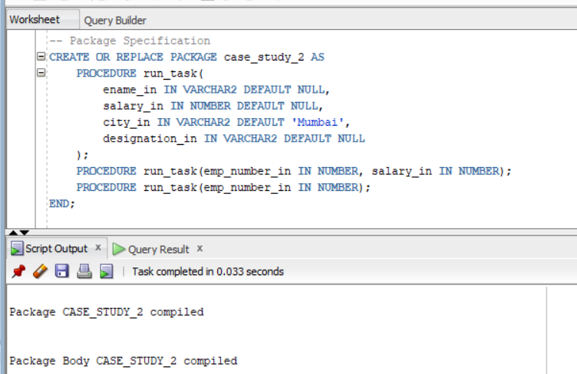

**6.5 Ensure all the Test cases defined are executed.**

1. Test case for 6.2

a) Valid case for add_emp

exec run_task(1, ename_in => 'Lewis', designation_in => 'Manager', salary_in => 6000, city_in => 'London');

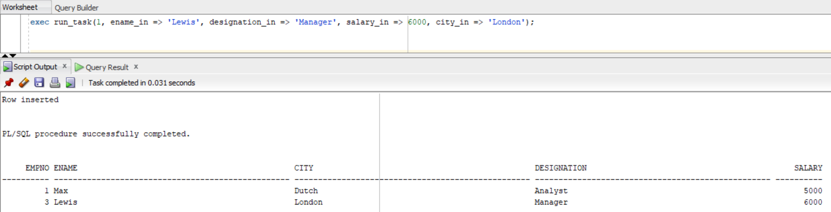

b) Case default location for add_emp

exec run_task(1, ename_in => 'Smith', designation_in => 'Manager', salary_in => 6000);

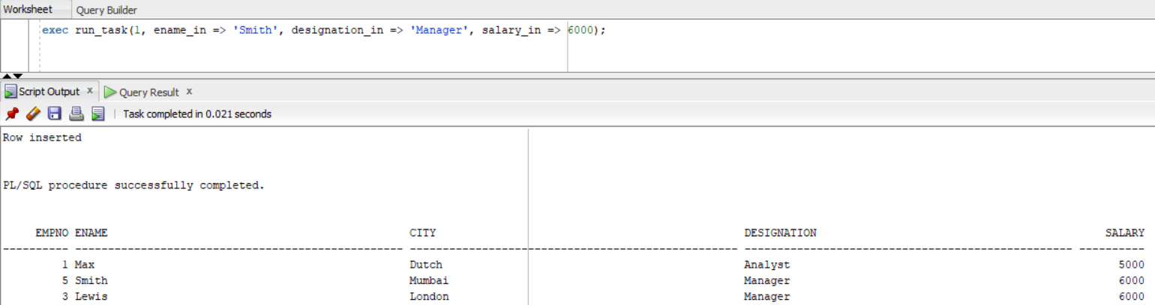

c) Valid case for raise_sal

exec run_task(2, emp_number_in => 5, salary_in => 6500);

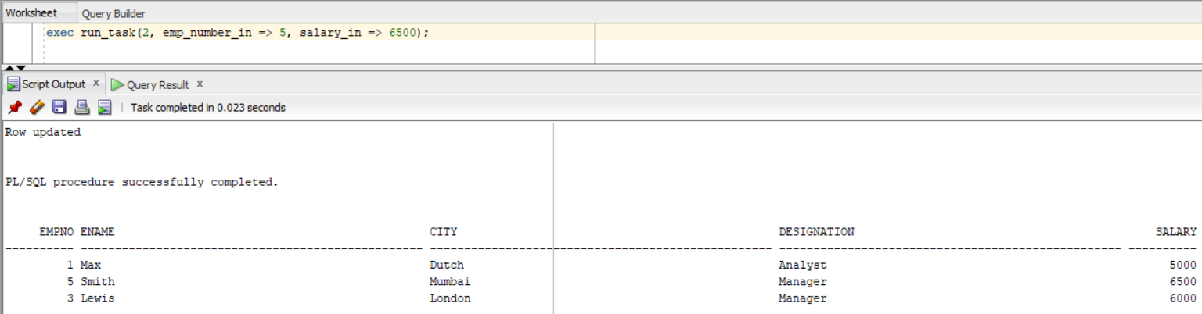

d) Invalid case for raise_sal

exec run_task(2, emp_number_in => 5, salary_in => 10000);

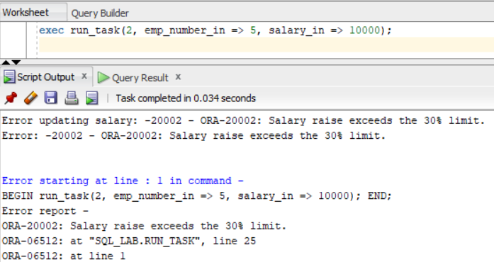

e) Valid case for remove_emp

exec run_task(3, emp_number_in => 5);

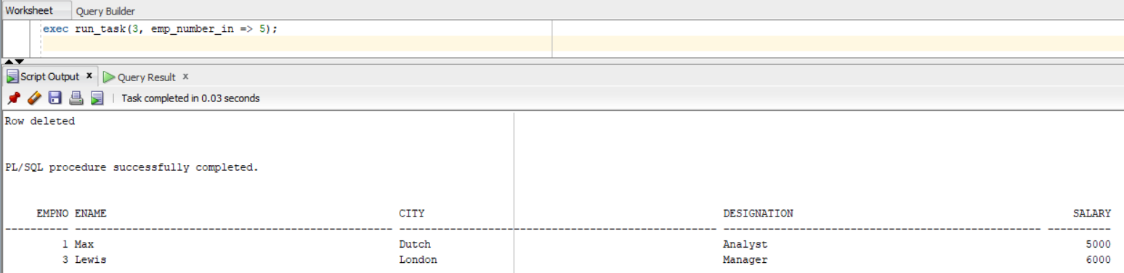

f) Invalid case for remove_emp

exec run_task(3, emp_number_in => 10);

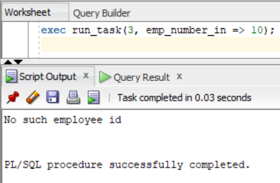

2.Test case for 6.3

a) Valid case for add_emp

exec add_emp('Max', 'Dutch', 'Analyst', 5000);

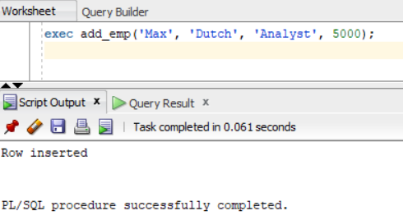

b) Case default location for add_emp

exec add_emp(v_ename => 'John', v_des => 'Analyst', v_sal => 5000);

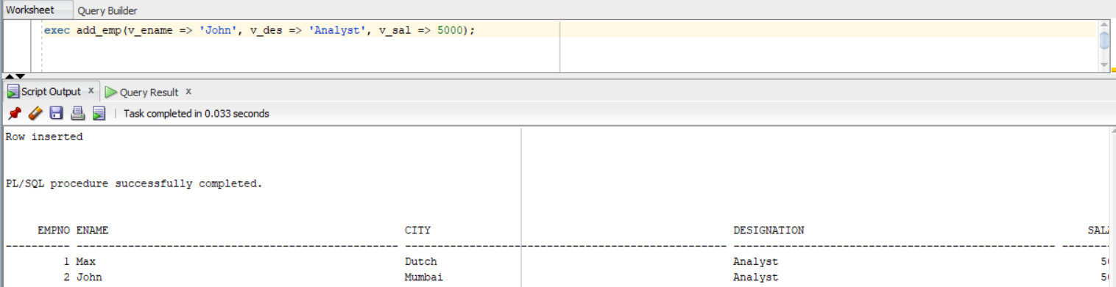

c) Valid case for raise_sal

exec raise_sal(2, 5100);

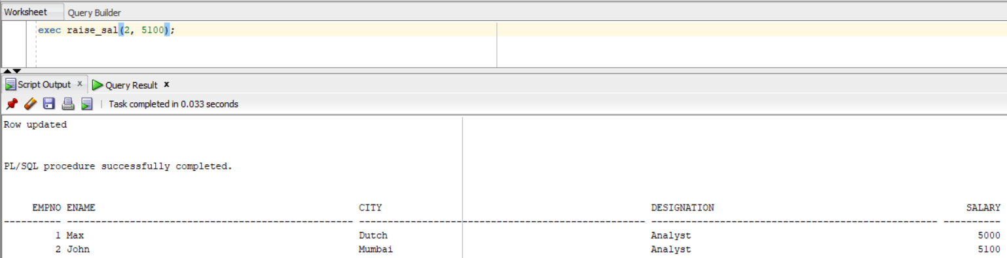

d) Invalid case for raise_sal

exec raise_sal(2, 8100);

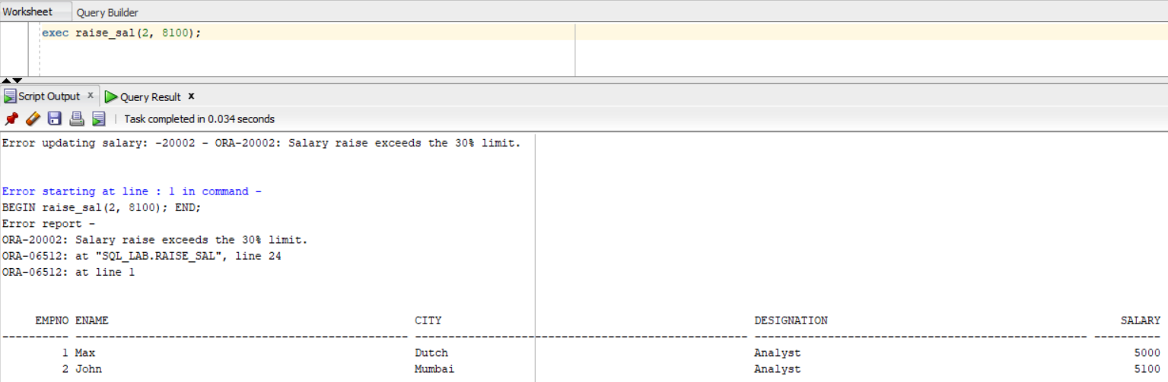

e) Valid case for remove_emp

exec remove_emp(2);

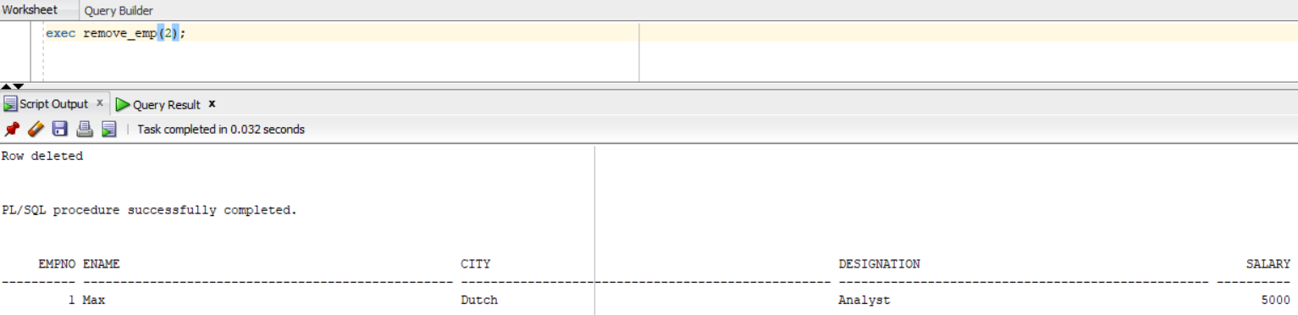

f) Invalid case for remove_emp

exec remove_emp(5);

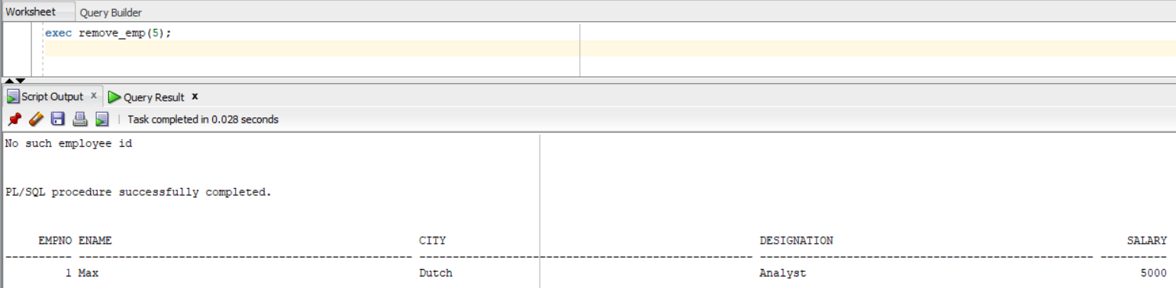

3. Test case for 6.4

a) Test Case for Inserting a New Employee:

exec case_study_2.run_task('John Doe', 50000, 'New York', 'Developer');

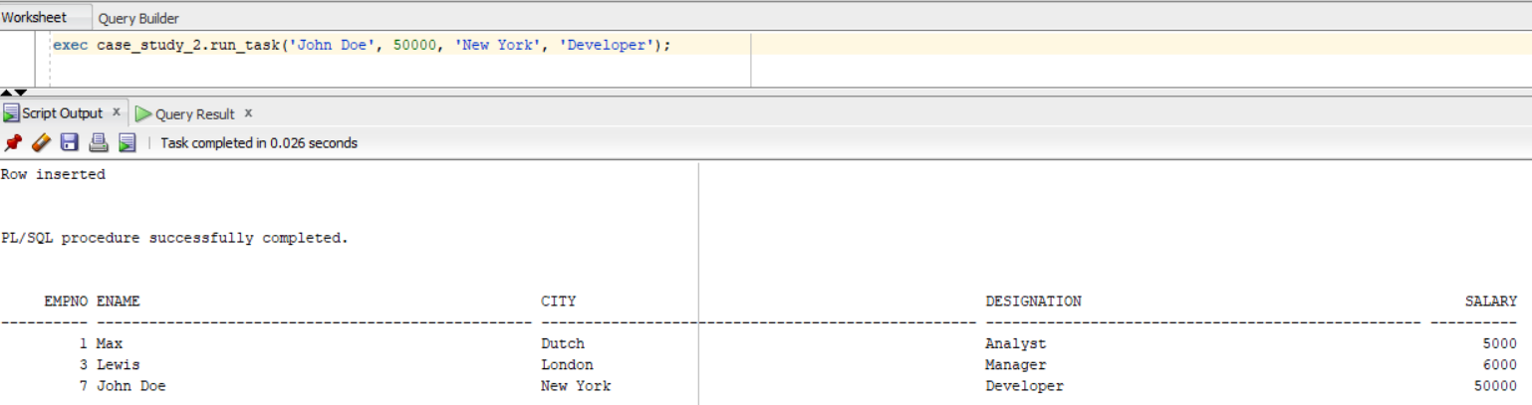

b) Test Case for Updating Employee Salary (within the limit):

exec case_study_2.run_task(1, 55000);

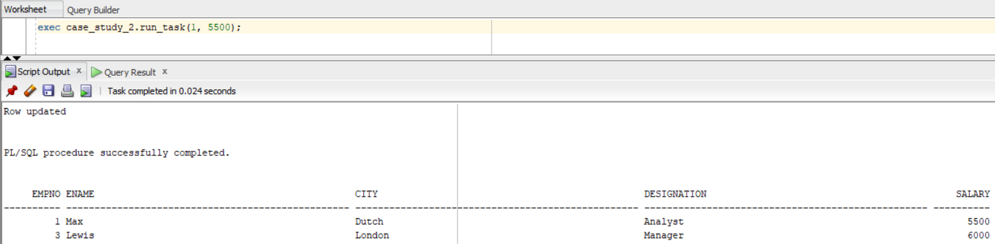

c) Test Case for Updating Employee Salary (exceeding the limit):

Exec case_study_2.run_task(1, 70000);

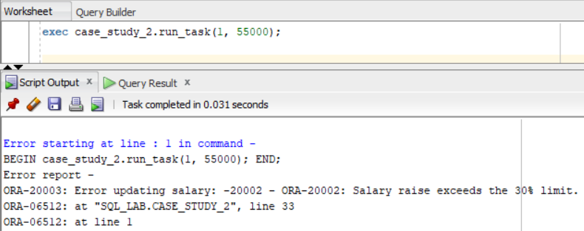

d) Test Case for Deleting an Employee:

exec case_study_2.run_task(3);

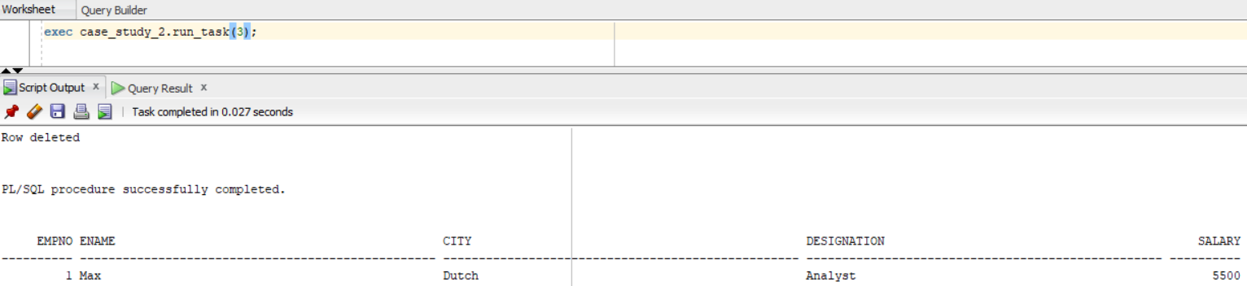

e) Test Case for Deleting Non-Existent Employee (no_data_found scenario):

exec case_study_2.run_task(999);

